**Usage of Card Game Interface**

**Components**

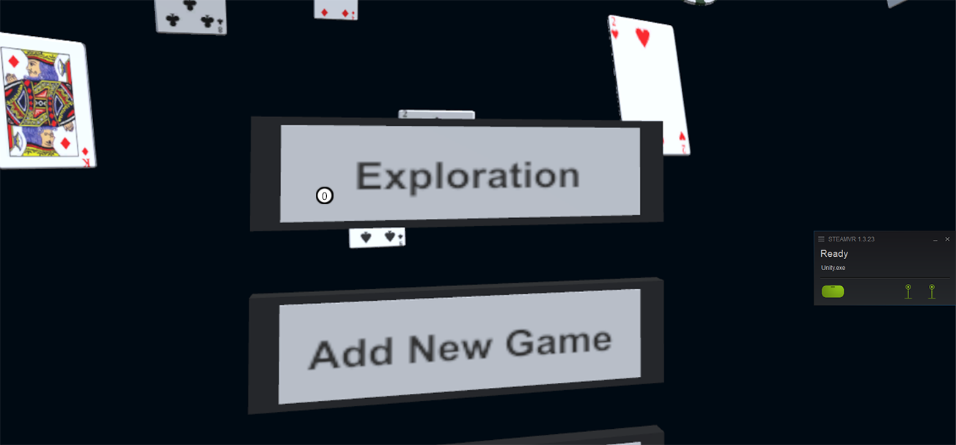

(0) Game title

(0.1) Exploration button: Start game

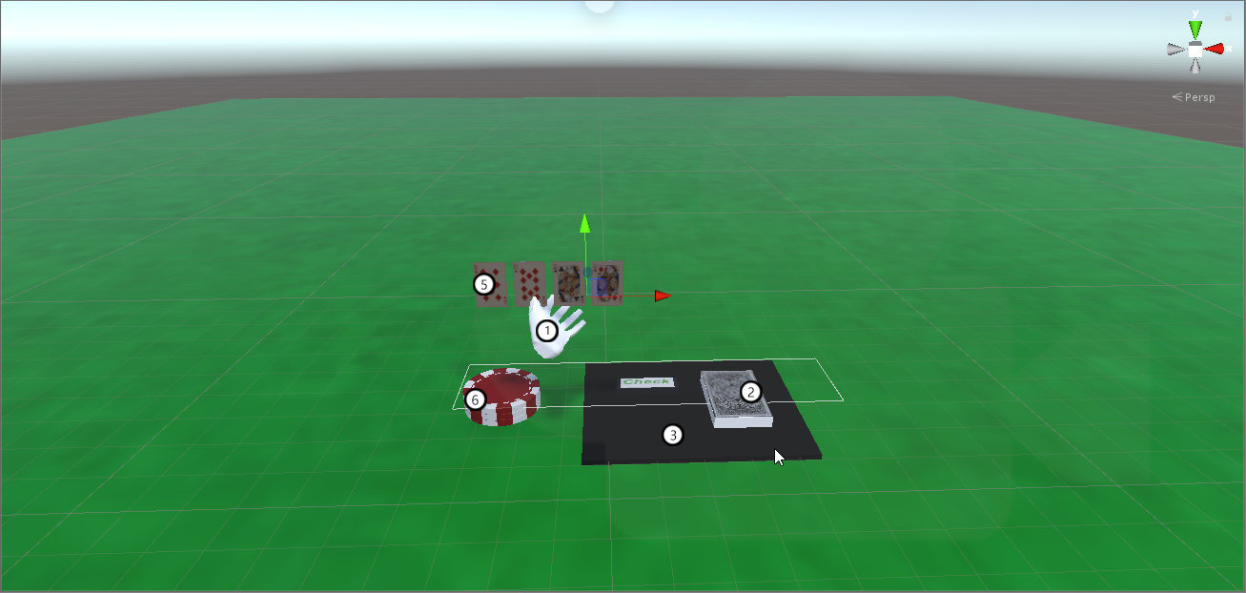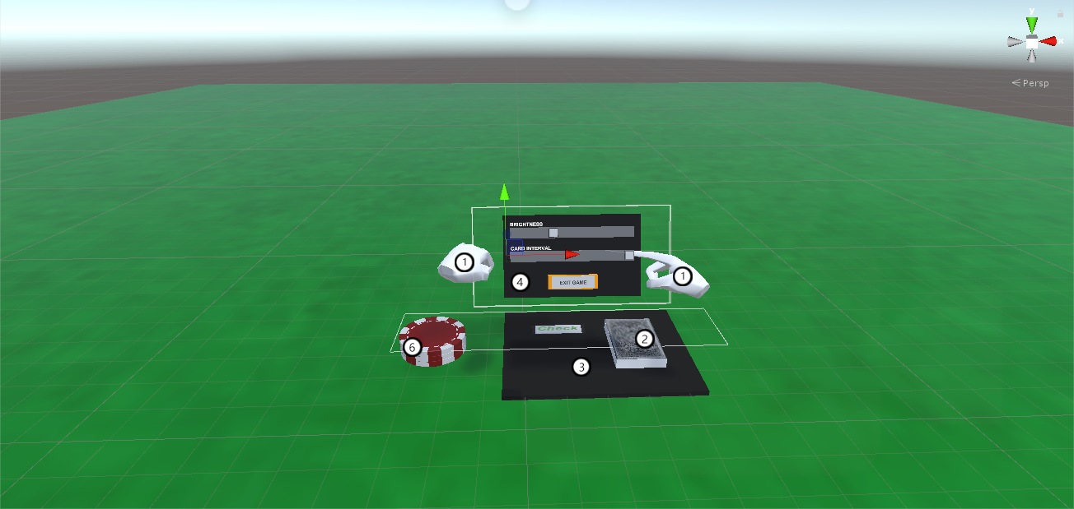

(1) Player hands

(2) Deck

(3) Deck Panel

(3.1) Check button: Tell your opponent to take their turn.

(4) Hand Panel

(4.1) Brightness slider: change the brightness of scene

(4.2) Card Interval slider: change the distance between cards in hand

(4.3) Exit Game button: go back to main menu

(5) Cards

(6) Chips

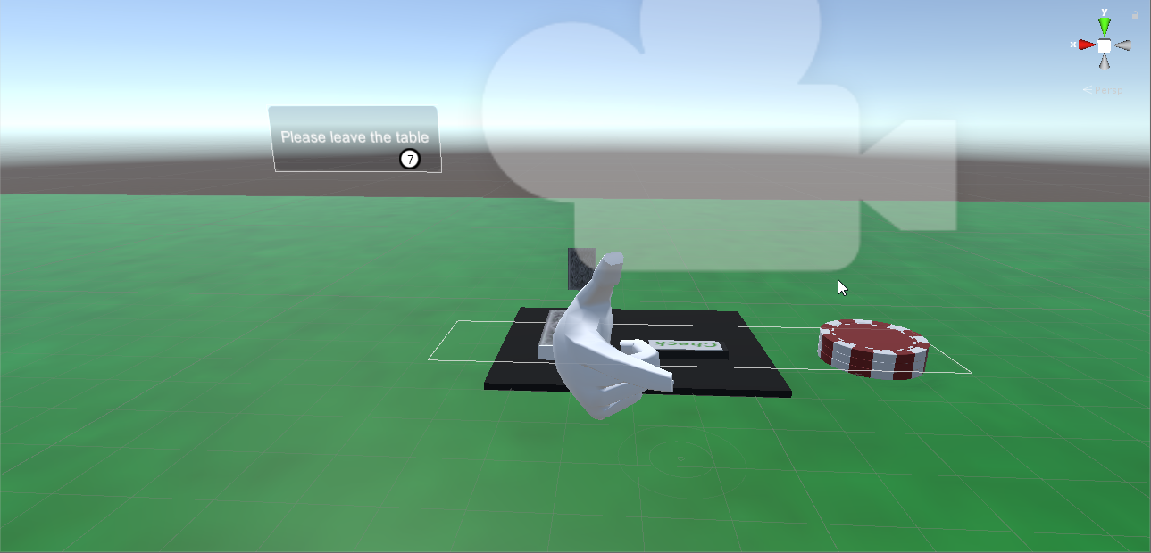

(7) Text box (opponent’s view)

**Supported Gestures**

Left hand:

(1) Place your left hand opened and upwards to show all cards in your hand

(2) Place your left hand closed (fist) and downwards to show the menu. Use right hand’s index finger to interact directly.

Right hand:

(3) Pinch a card from anywhere (index finger pointing to card)

(4) Grab a chip (index finger’s tip inside the chip object)

(5) Swipe inward on the deck to draw a card

(6) When showing the cards in left hand, snap (only thumb, index, middle finger extended and thumb is close to middle finger) to use black magic

(7) Thumb down to taunt (text UI)

(8) Clap to say gg

(9) Pistol gesture (finger and thumb extended) for threatening, rotate pistol along x axis to fire